**PRACTICAL - 4**

(1)

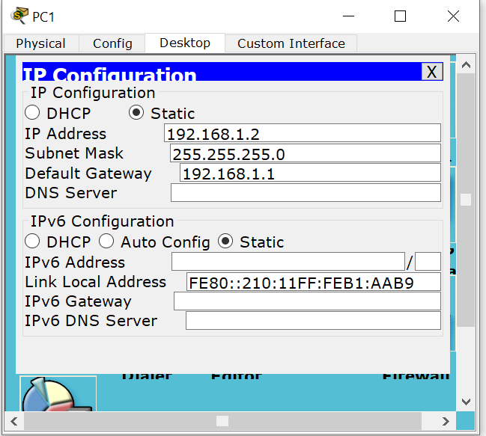

(2)

PC>ping 192.168.4.2

Pinging 192.168.4.2 with 32 bytes of data:

Reply from 192.168.4.2: bytes=32 time=0ms TTL=127

Reply from 192.168.4.2: bytes=32 time=0ms TTL=127

Reply from 192.168.4.2: bytes=32 time=0ms TTL=127

Reply from 192.168.4.2: bytes=32 time=0ms TTL=127

Ping statistics for 192.168.4.2:

Packets: Sent = 4, Received = 4, Lost = 0 (0% loss),

Approximate round trip times in milli-seconds:

Minimum = 0ms, Maximum = 0ms, Average = 0ms

(3)

PC>tracert 192.168.4.3

Tracing route to 192.168.4.3 over a maximum of 30 hops:

1 5 ms 0 ms 0 ms 192.168.1.1

2 1 ms 1 ms 0 ms 192.168.4.3

Trace complete.

(4)

PC>ping 192.168.1.2

Pinging 192.168.1.2 with 32 bytes of data:

Reply from 192.168.1.2: bytes=32 time=0ms TTL=127

Reply from 192.168.1.2: bytes=32 time=0ms TTL=127

Reply from 192.168.1.2: bytes=32 time=0ms TTL=127

Reply from 192.168.1.2: bytes=32 time=0ms TTL=127

Ping statistics for 192.168.1.2:

Packets: Sent = 4, Received = 4, Lost = 0 (0% loss),

Approximate round trip times in milli-seconds:

Minimum = 0ms, Maximum = 0ms, Average = 0ms

(5)

PC>tracert 192.168.1.3

Tracing route to 192.168.1.3 over a maximum of 30 hops:

1 0 ms 1 ms 0 ms 192.168.4.1

2 0 ms 0 ms 0 ms 192.168.1.3

Trace complete.